EXPT NO:2 | Regression and Optimization (Linear and Logistic regression)
DATE: 30.01.2026 | Regression and Optimization (Linear and Logistic regression)

Name : Swasthika M
Roll no : 24BAD121

PRE-LAB QUESTIONS :

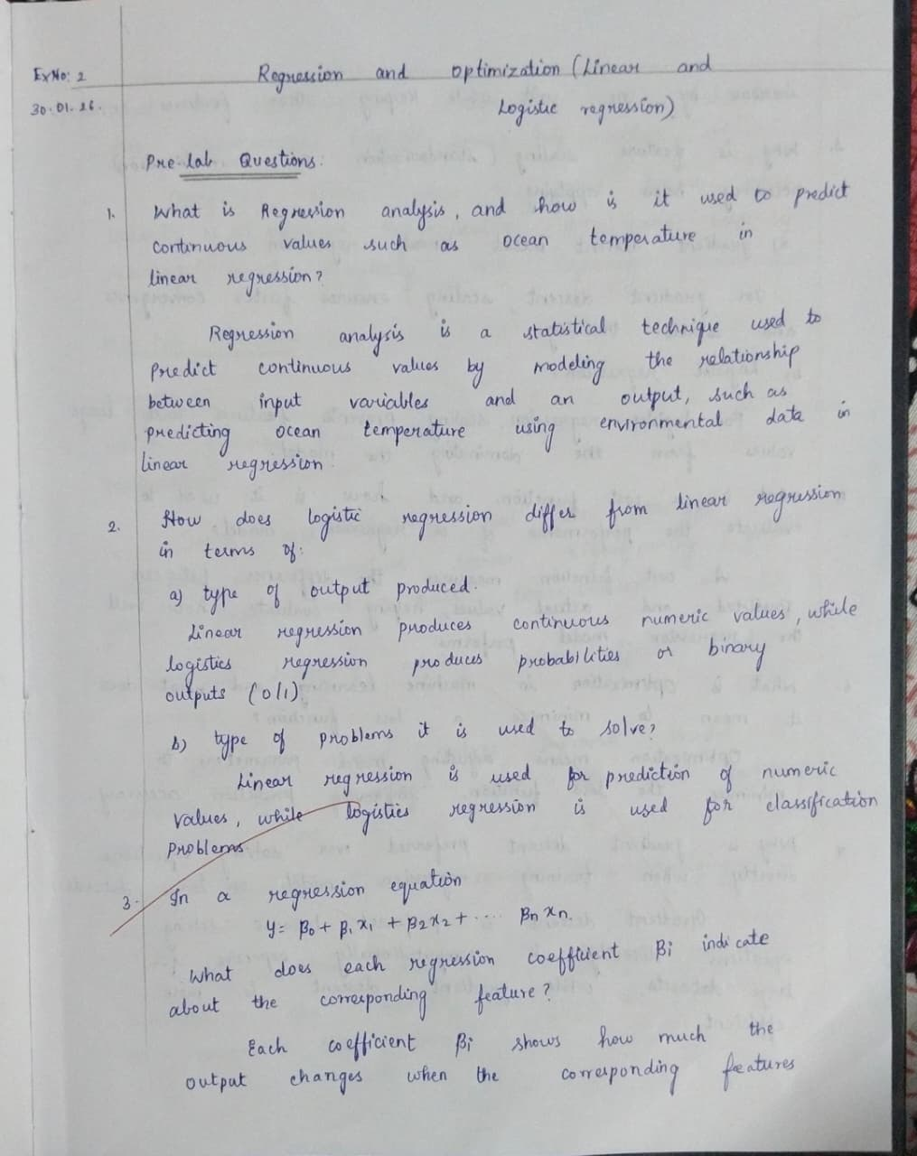

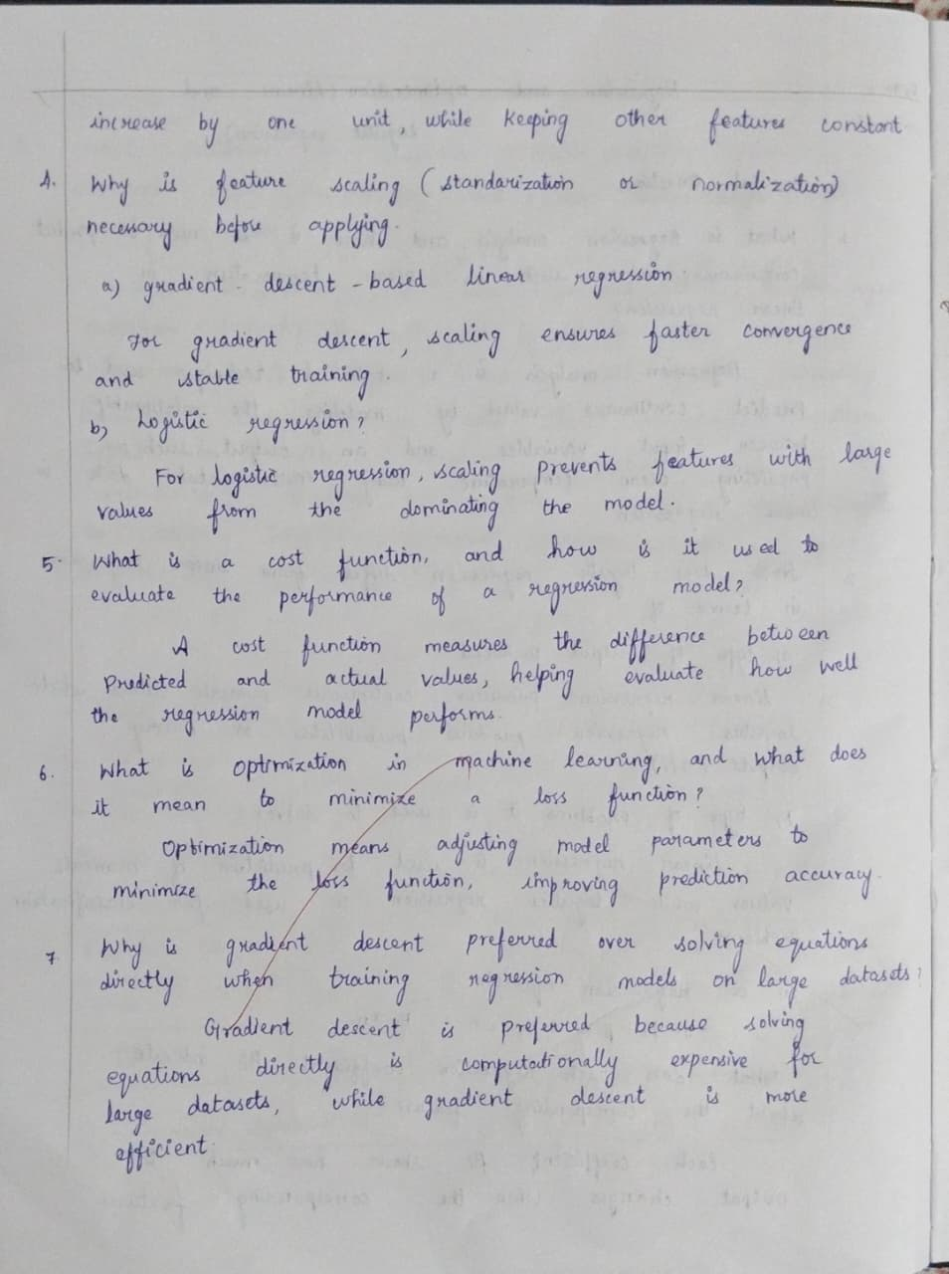

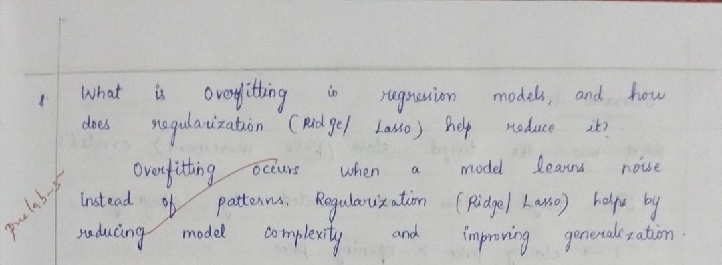

IN-LAB EXERCISE
OBJECTIVE:
To implement and optimize linear regression and logistic regression models using real-world datasets and analyze their performance.

SCENARIO 1:
Predict ocean water temperature using environmental and depth-related features.
Dataset (Kaggle – Public):
https://www.kaggle.com/datasets/sohier/calcofi
Target Variable:
- Water Temperature (T_degC)
Sample Input Features
- Depth (m)
- Salinity
- Oxygen
- Latitude
- Longitude

IN-LAB TASKS
- Import necessary Python libraries (NumPy, Pandas, Matplotlib, Seaborn, Scikit-learn).
- Load the CalCOFI dataset into a Pandas DataFrame
- Select relevant numerical features and target variable.
- Handle missing values using mean/median imputation.
- Perform feature scaling using StandardScaler.
- Split the dataset into training and testing sets.
- Train a Linear Regression model using Scikit-learn.
- Predict water temperature for test data.
- Evaluate model performance using:
– Mean Squared Error (MSE)
– Root Mean Squared Error (RMSE)
– R² Score
- Visualize:
– Actual vs Predicted temperature
– Residual errors
- Optimize model performance using:
– Feature selection
– Regularization (Ridge / Lasso)

Code :

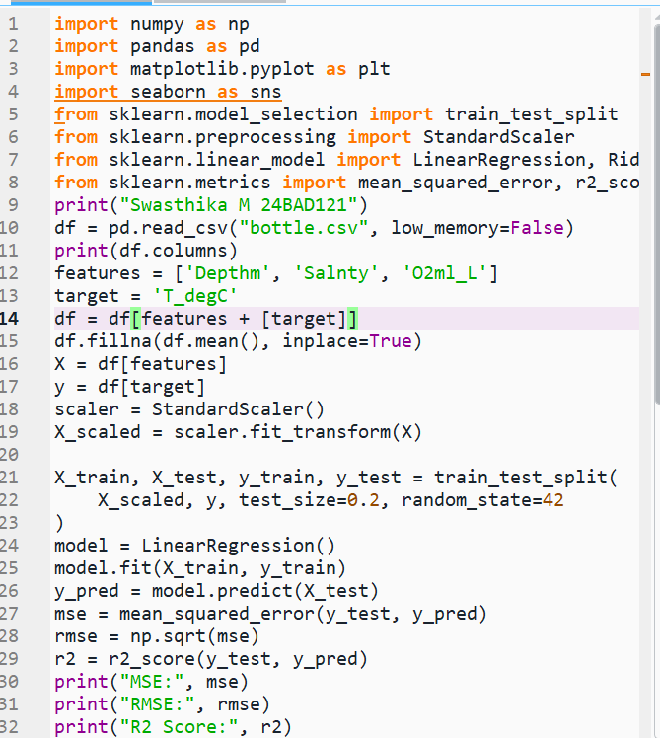

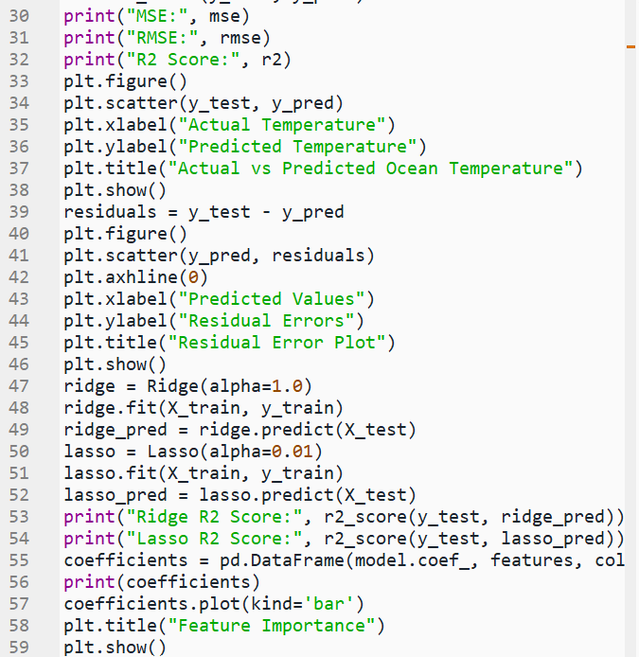

Output:

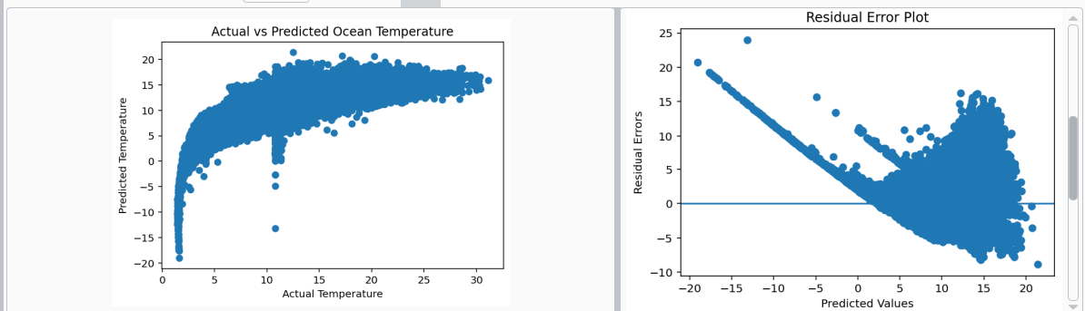

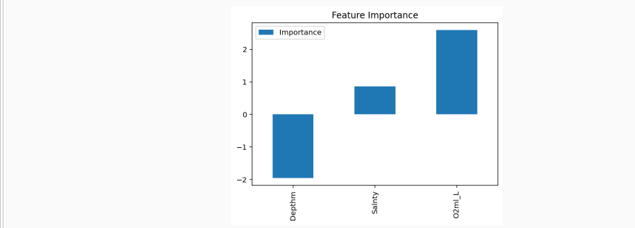

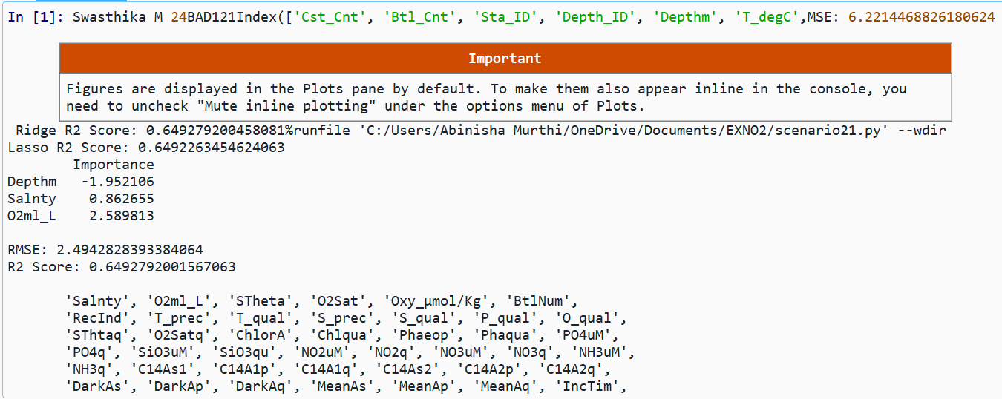

SCENARIO 2:
Classify whether LIC stock price will increase (1) or decrease (0) based on historical data.
Dataset (Kaggle – Public):
https://www.kaggle.com/datasets/debashis74017/lic-stock-price-data
Target Variable (Derived):
• Price Movement
– 1 → Closing price > Opening price
– 0 → Closing price ≤ Opening price
Input Features:
• Open
• High
• Low
• Volume

IN-LAB TASKS (Logistic Regression)
- Import required Python libraries.
- Load LIC stock dataset into Pandas.
- Create a binary target variable (Price Movement).
- Handle missing values.
- Perform feature scaling.
- Split the dataset into training and testing sets.
- Train a Logistic Regression model.
- Predict stock movement for test data.
- Evaluate classification performance using:
– Accuracy
– Precision
– Recall
– F1-Score
– Confusion Matrix
- Visualize:
– ROC Curve
– Feature importance
- Optimize model using:
– Hyperparameter tuning (C, penalty)
– Regularization

Code :

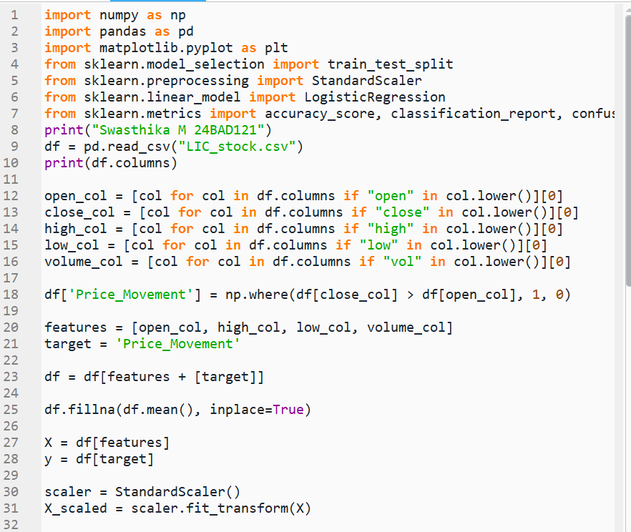

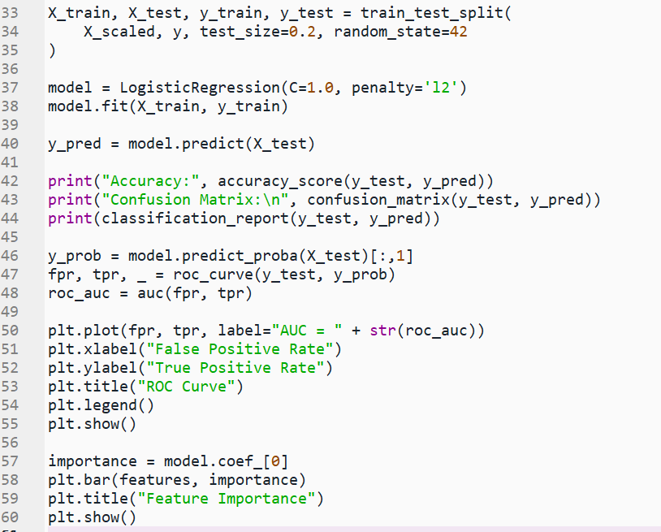

Output :

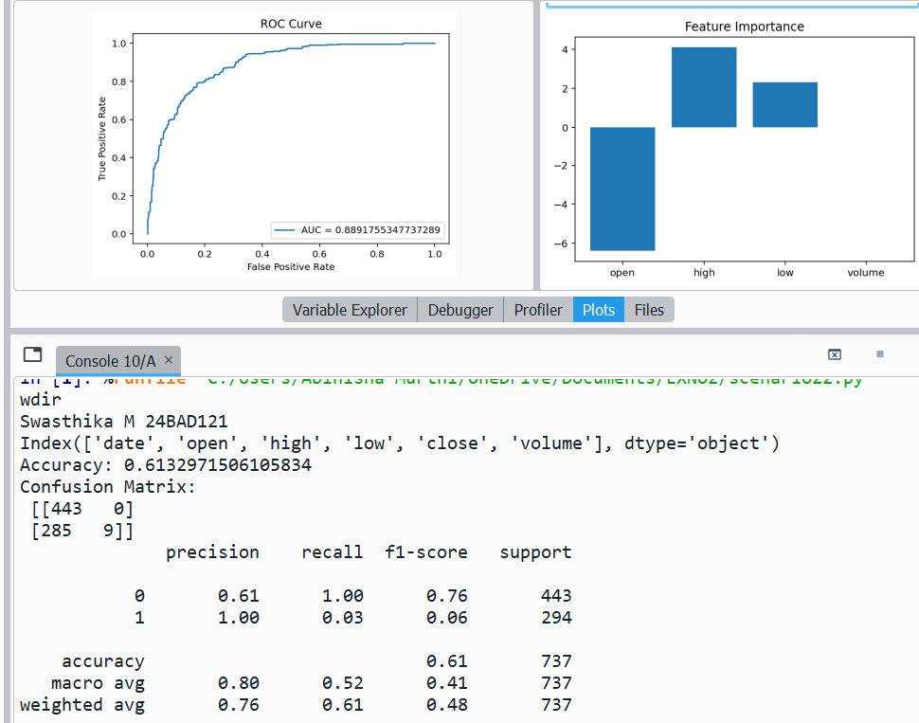

POST-LAB QUESTIONS :

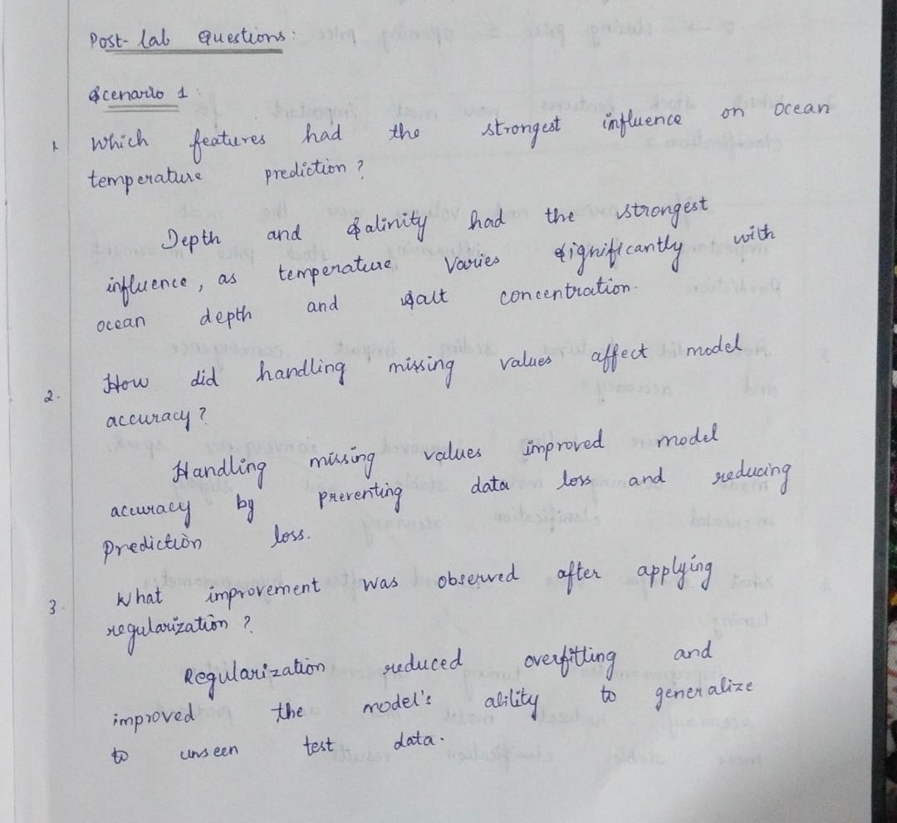

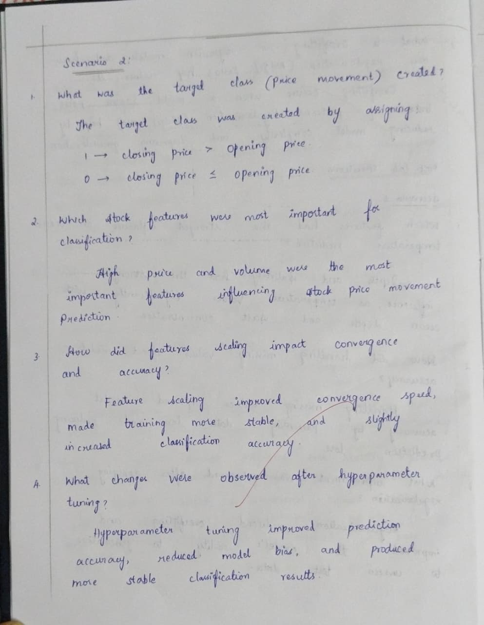

ASSESSMENT

